**Design Project­**

**MECH 323 Machine Design (Winter 2021)**

|  |  |  |  |
| --- | --- | --- | --- |
| **Team Number** | **44** | | |
|  | | | |
| **Phase Number** | **4** | | |
|  | | | |
| **Team Members** |  | **Student Number (Required)** | **Student Name**  **(Optional)** |
| **1** | **20113369** | **Vanessa Noel** |
| **2** | **20116486** | **Owen Cox** |
| **3** | **20054130** | **Nikita Ravindran** |
| **4** | **20114391** | **Alexander Parks** |
| **5** | **-** | **-** |
|  | | | |
| **Mark** |  | | |

*Statement of Originality: “The title page containing the name above asserts that this is a wholly original work by the author, and any shared and external contributions to this work are documented within.”*

Table of Contents

Executive Summary 3

Introduction 4

1.0 Gearbox Evolution 5

1.1 Gearbox – Phase One 5

1.2 Gearbox – Phase Two 5

1.3 Gearbox – Phase Three 6

2.0 Final Gearbox Design 8

2.1.0 Housing 8

2.1.1 Requirements and Constraints 8

2.1.2 Justification of Design 8

2.2 Shaft Design 9

3.0 Technical Specifications 11

3.1.0 Tools Required: 11

3.1.1 Assembly Instructions 11

3.1.2 Parts List 16

3.2 Technical Specifications Summary 16

4.0 Future Work Recommendations 18

Conclusion 19

Appendix A 21

Appendix B – Drawing Package 22

# Executive Summary

The main focus of Phase 4 was the design of the gearbox housing and the modifications to the design of gears and shafts to ensure it is suitable for 3D printing. The main modifications were made to account for the change in material from AISI 4130 steel to 3D printed ABS plastic.

All keyways were replaced with splines to couple gears and shafts. This accounts for the low shear strength between 3D printed layers. Retaining ring features from previous designs were removed as they were no longer necessary. While modifying the shaft diameter with the smallest safety factor by 10-20% was recommended to act as a buffer for the difference in strength between materials, it was deemed unnecessary as the critical points with the lowest safety factor had been removed from the design altogether when splines were used in the design.

The housing supports the shafts and holds them in the correct position and orientation, and so the housing was designed to withstand all the resultant forces from the shafts. This was achieved by incorporating truss geometry in the design of the housing panels. This structure distributes the forces across the triangles in the housing panels. The truss structure primarily experiences tension and compression and significantly minimizes bending moment, which is an added advantage in ensuring the strength and stability of the housing. To meet size constraints while maintaining truss geometry, supports were added between truss triangles. The final housing design minimizing the weight and the print time, while providing necessary support and strength to the internal components.

The gearbox design contains a single-stage shifting gear set. This requires two shafts, with 2 sets of gears that alternate between the top-speed event and the hill-climb event. Each shaft was determined to be safe and stable considering the forces and fatigue strength they will be subjected to.

Overall, the gearbox consists of an input shaft, an output shaft, a pinion, a gear, five housing panels and four bushings. The technical specifications of these components are summarized in table 1. The gearbox components were checked for compatible fit using SolidWorks and all parts fit together to produce a compact final gearbox. The assembly instructions are detailed step-by-step in Section 3 of this report.

All the requirements and constraints stipulated in the project checklist were met by the final design. The overall print time for all the components is 5 hours and 46 minutes, which is well under the time limit of 9 hours.

# Introduction

Phase 4 culminates the gearbox design process and focuses on adapting the features of the gears and shafts to be suitable for 3D printing. A housing structure for the gearbox was then designed while ensuring it met dimension requirements and that all components fit within it.

Several modifications were incorporated into the design with the change in material from AISI 4130 steel in previous phase reports to 3D printed ABS plastic. The shafts will not be printed axially to avoid separation of layers due to torsion. To secure the sprockets on the shafts, the section at either end of the shafts was modified to a D-shaft. All keyways were replaced with splines in order to couple gears and shafts to account for the low shear strength between 3D printed layers. Retaining ring features from previous designs were removed as they were no longer necessary, since the gears will rely on a frictional fit. This was followed by selecting suitable bushings.

The housing was designed to be strong enough to restrain all the forces exerted by the shafts. The location and orientation of bearings and shafts were taken into consideration when designing the housing so that the gearbox as a whole is stable and doesn’t come apart when in use. Furthermore, the parts were joined such that they would remain assembled without any external additions or restraints. The attachments between housing panels were chosen with the intention of making the gearbox easy to assemble and disassemble for testing purposes.

Catalyst software was used to ensure that all parts could be printed within the time limit of 9 hours and that all the components could be arranged within the print bed area. The orientation of components was carefully considered for the 3D printing process, which uses Fused Deposition Modelling (FDM) with small diameter ABS plastic filament. This was done to account for the possibility of separation of layers of plastic due to loads or torsion when the gearbox is in use.

SolidWorks was used to digitally check how parts fit together, and to demonstrate the assembly procedure of the gearbox by breaking it down into stages that are easy to follow.

# 1.0 Gearbox Evolution

## Gearbox – Phase One

The goal of phase 1 was to create a rough draft and detail the first technical specifications of the design. Because there were two separate events that the gearbox would have to be designed, the team had to choose which one to focus on. The hill climb event would require the most torque output and would allow for a smaller range of gear ratios, so it was decided that the primary objective for the first iteration of the design was to maximize the angle of incline the car was able to reach. With a known center of mass and a known coefficient of friction, a detailed free-body diagram was created of the back wheels on the ramp. When the force of friction equalled the force of gravity pulling the car down the ramp, a slip would occur, stalling the movement of the car up the ramp. The angle at which this occurred was found for the 4 different possible masses of the car. A spreadsheet was created comparing the torque required to reach the maximum angle at each mass to the maximum torque output of the gearbox at the maximum torque of the motor. The maximum RPM of the motor and subsequently, the wheels, was then found at each gear ratio.

The gear ratio with the highest top speed would then be chosen to stay competitive in the top speed event. However, while calculating the straight-line top speed, a mistake was made; instead of using the given rolling resistance to find the stall toque of each gear ratio, the required torque for the ramp was used. This meant that the top speed found in phase 1 was drastically wrong, with higher gear ratios showing to have a higher speed, however, it was overlooked by the team in phase 1 due to a lack of experience.

The outcome of phase 1 was a single-stage gearbox with a gear ratio of 2.9:1, designed for the operation of a car of 15-kilogram mass. It was designed to reach a maximum angle of 27.47 degrees on the ramp, which equals a distance of 0.503 meters in under 5 seconds, and achieve a speed of 0.415 m/s which allows it to drive the 2-meter course in about 4.82 seconds.

## Gearbox – Phase Two

The second phase of the project saw a complete overhaul of the gearbox design. As mentioned in the conclusion of phase 1, the team was not fully satisfied with the first iteration of the design, as it was not optimized for the top-speed event. It was noticed that because the torque due to the resistive forces in the top-speed event was significantly lower than the maximum torque produced by the motor, a gear ratio of below 1:1 could be used, possibly improving the speed achieved by the vehicle in a straight line. Additionally, a factor of safety of 1.2 was used for the torque calculations in phase 2, something that was not done in phase 1. While 1.2 can be considered excessive, this was done to make sure that the design would not fail under extreme circumstances, and to account for the added mass of the gearbox. A spreadsheet of the top speeds of gearbox ratios of 0.3:1 to 0.7:1 at an increment of 0.01:1 was made for the 15 to 18.75-kilogram masses. It was found that the speed achieved by the heavier car was almost half the value of the lighter, 15-kilogram car. It was found that the highest speeds of the vehicle could be achieved with gear ratios in the range of 0.4:1 to 0.6:1, with the safety factor included.

The gearbox was switched to a single-stage shifting design. This was done to combine the research and calculations done in phase 1 with the new calculations and come up with 2 gear ratios that could be switched between events to maximize performance in each event. For reasons of simplicity, the gear ratios to be chosen were decided to be inversely proportional. This meant that the gear and pinion designed for one event could be switched order for the other event. With the inverse gear ratios, this meant that the gear ratio for the top speed had to be under 0.47:1, as its inverse is above the threshold of 2.2 gear ratio for the hill climb event. The final gear ratio that was settled on was 0.4:1 for the top speed event and 2.5:1 for the hill climb event. This provided significant speed as well as ease of gear design with those specifications.

## Gearbox – Phase Three

The objective of Phase 3 was to complete shaft analysis and any necessary redesign. This section focused on the hill climb event since the shafts would deliver torque from the input motor to the wheels of the car. A thorough shaft analysis was performed, including calculating the corrected endurance limit, determining forces and torques along the input and output shafts, identifying critical points along both shafts, and constructing bending moment and torque diagrams.

Various factors that could affect the shafts’ fatigue limit while in use outside of a controlled environment were considered to calculate the corrected endurance limit. While most of the factors were less than or equal to 1, the size factor was 1.973. This increased the endurance limit by 8.8%, from 640 MPa to 696.306 MPa. which effectively makes the shaft safer and more reliable since it can withstand a high number of cycles at greater stress.

Free body diagrams of the shafts and gears were made to locate forces. Using sums of moments and sums of forces, the reaction forces on each of the components were calculated. This step helped ensure that the structure was stable and that none of the forces were large enough to lead to the failure of any parts.

The next stage of Phase 3 looked at identifying critical points by considering discontinuities, bearings, keyways, and shoulders. The static and dynamic stress concentration factors for both bending and torsion were calculated for all the critical points. The stress concentration factors relate the actual maximum stress at discontinuities to the nominal stress. The highest value of stress concentration factor was at a keyway in the output shaft, with a value of 2.1 for static normal bending, which is still well below the threshold for fatigue failure. It is important to note that the material of the shafts is AISI 4130 steel, and so the effects of brittle failure were carefully considered. Given that the 3D printed version will be made of ductile ABS plastic, the values can vary; however, the stress concentration factors focus on the geometry of the structure rather than the material itself and so they would hold true despite the material change.

The stress concentration factors were then used to determine the safety factors at each critical point using the DE-Gerber criterion. The lowest factor of safety was 6.05 at a keyway of the input shaft, which is significantly high. Lastly, bending moment and torque diagrams were created for each of the shafts. The goal was to have each overall factor of safety for components greater than 1. It was found that all of the safety factors for components exceeded 1, with the smallest safety factor approaching 3.

Phase 3 as a whole focused on ensuring the stability and safety of the shafts, while also accounting for design changes from Phase 2, such as the change in gear face width from 7 mm to 10 mm to meet safety factor requirements. The shaft diameter was chosen carefully to balance the need for high torsional stiffness and resistance to bending, without adding too great a mass that would impact the car’s performance in the hill climb or top speed event. Phase 3 sets the groundwork to bring together the work of all the previous phases for a final Phase 4.

# 2.0 Final Gearbox Design

## 2.1.0 Housing

The housing is an extremely important part of this project as it provides support for the shafts, protects the key components from the environment (this more so applies to completely sealed housing designs), and ensures all the parts are aligned correctly. Given that the housing had not been considered until this phase, the team focused on ensuring that the housing was made properly (i.e., met all the requirements and followed the guidelines). The highlights of the team’s housing design are that it is strong, it utilizes a truss design to redistribute the bending moments as pure tension and compression, and it meets all of the requirements and constraints outlined in the instructions, and it can be printed in under six hours (the estimated print time is five hours and forty-six minutes).

### 2.1.1 Requirements and Constraints

This section discusses the requirements and constraints that were outlined in the instructions as well as, the other factors the team considered when designing the housing. For a detailed list of the requirements of the housing and its dimensioning, see the checklist document for greater details.

As previously discussed, the housing supports the shafts and holds them in place. This means the housing needs to be able to withstand all the forces it will endure due to the rotation of the shaft and the movement of the other parts. Moreover, the way in which the pieces of the housing are joined together needs to provide adequate support whilst still being able to be taken apart and reassembled when needed. This constraint adds a level of complication to the housing design since it cannot simply be put together and then given some form of strength enhancement (e.g., gorilla glue, hot glue, etc.). Furthermore, there was a limit on the print time. The time it takes to print all the parts could not exceed nine hours and if it could be printed in less than six hours, extra points would be awarded. Lastly, in the instructions, there were several given dimensions that could not be altered. This constraint was given to ensure that the gearbox could fit in the vehicle but it limited the team’s ability to find creative ways to reduce print time and the amount of material used (and as a result, the cost). All the constraints outlined above are related to the strength of the housing. As a result, the team prioritized making the final design as strong as possible while still meeting the requirements.

### 2.1.2 Justification of Design

Since there was a constraint that stated all parts needed to be printed in less than nine hours, the housing needed to have cutouts to be printed in time. The challenge was figuring out where those cutouts should go. If the cutouts were not carefully placed, the housing could have failed (i.e., cracked or completely broken).

To ensure the housing would not fail, the cutouts were designed such that they resemble a truss. Trusses are extremely useful because they take a load/force and distribute it down both sides of the triangles. This results in all three sides of the triangle being in either tension or compression. The resulting design weighs less and is stronger since the load can be distributed over many members.

Given the size constraints, producing a housing design with equilateral triangles was not possible. As a result, ‘support beams’ were added to the sides of the housing where needed. These beams provide extra support to account for the fact the distribution of the force on each side of the triangle will be somewhat uneven which meant certain spots would be more prone to failure. The front, and back feature a full truss and the left and right both have two cutouts. One allows the gear to freely rotate and the other, allows the belt to be attached. Without these cutouts, the size of the gear (and thus, the torque) would have needed to be reduced.

The final housing design provides adequate strength whilst minimizing the weight, and the print time. It should be noted that all the components for the gearbox have an estimated print time of five hours and forty-six minutes, as shown in Figure 12 which can be found in appendix A. Furthermore, all the constraints and requirements listed above were met.

## 2.2 Shaft Design

The gearbox design contains a single-stage, shifting gear set. This requires two different shafts, each designed to hold either the gear or the pinion for a given event.

The input shaft is meant to hold the gear for the hill climb event, and the pinion for the straight-line event. The output shaft is meant to hold the pinion for the hill climb event, and the gear for the straight-line event. Each shaft is designed to withstand stress due to bending and torsion experienced during the events. Calculations were done in phase 3 to determine the fatigue stress concentration factors at each critical point on the shafts, corrected endurance limit, and torque and bending moments at critical points for an endurance test. The endurance test simulated the gearbox operating for 24 hours a day, 7 days a week, for 5 years at the slip point on the hill climb event.

Each shaft performed well, and it was determined that each shaft design was safe and stable in withstanding the forces and fatigue stress it would be subjected to throughout the events.

Furthermore, the smallest safety factors for each shaft were located at keyways and snap ring grooves. The keyways on the shafts were replaced with spline connections, and snap ring grooves were removed because each gear is set by a frictional fit. Therefore, it was decided that there was no need to increase shaft diameters, as it would increase print time and the critical points with the lowest safety factors had already been removed.

D-profiles were added to each shaft to secure the sprockets in place. The D-profiles on the input and output shafts have diameters of 10mm and 8mm, respectively and a depth of 1mm.

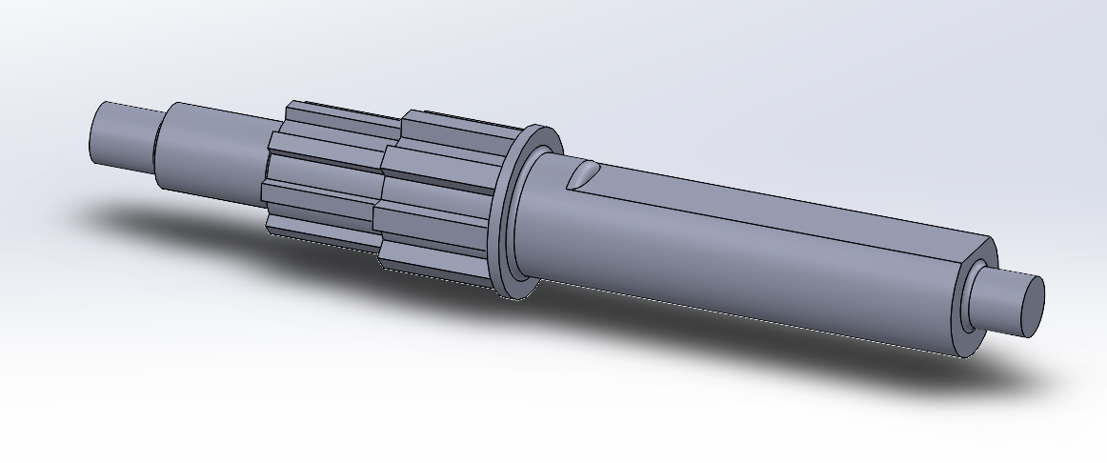

Figure 1 - Input shaft design

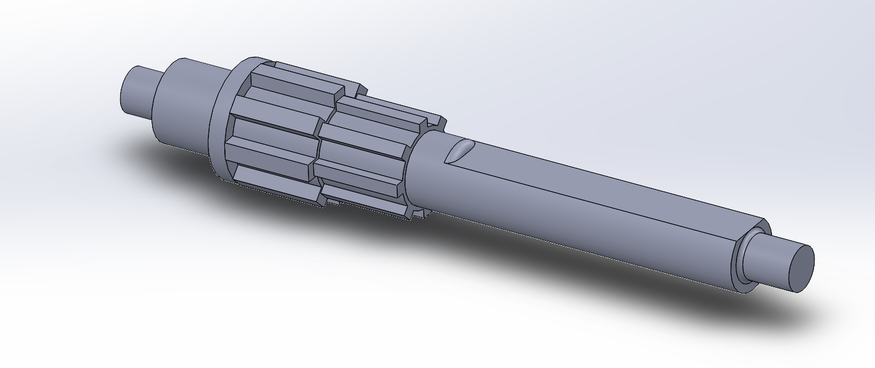

Figure 2 - Output shaft design

# 3.0 Technical Specifications

### 3.1.0 Tools Required:

The tools required to make the gearbox are Fortus 380mc (Stratasys) FDM printer using ABS thermoplastic. There are no additional tools need for the assembly of the gearbox.

### 3.1.1 Assembly Instructions

Below is the detailed assembly procedure for the gearbox. It should be noted that the gearbox is being set up for the hill climb event. Steps one and two vary depending on the event.

Step One – Take the input shaft (shown below) and place the gear on it. (For the straight-line event, place the pinion on the shaft)

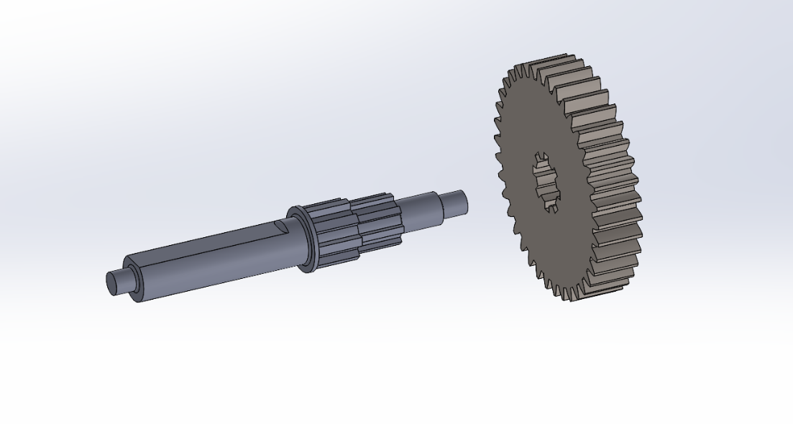

Figure 3 - Attaching the Input Shaft to the Gear

Step Two – Place the pinion on the output shaft. (For the straight-line event place the gear on the shaft)

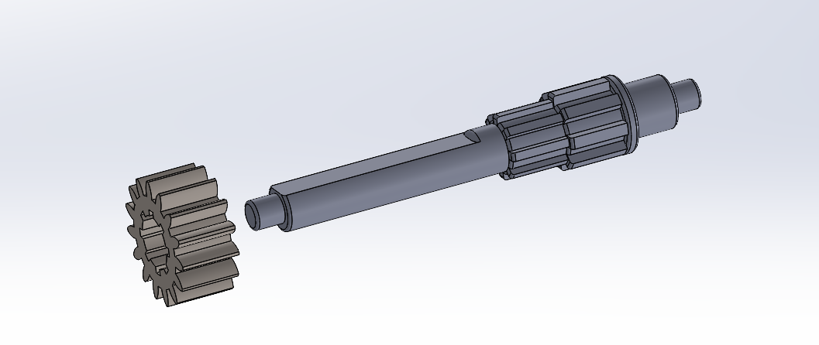

Figure 4 - Attaching the Pinion to the Output Shaft

Step Three –Locate the two side panels (pictured below) and take four bearings and place each one, in one of the four holes against the shoulder (two holes per side).

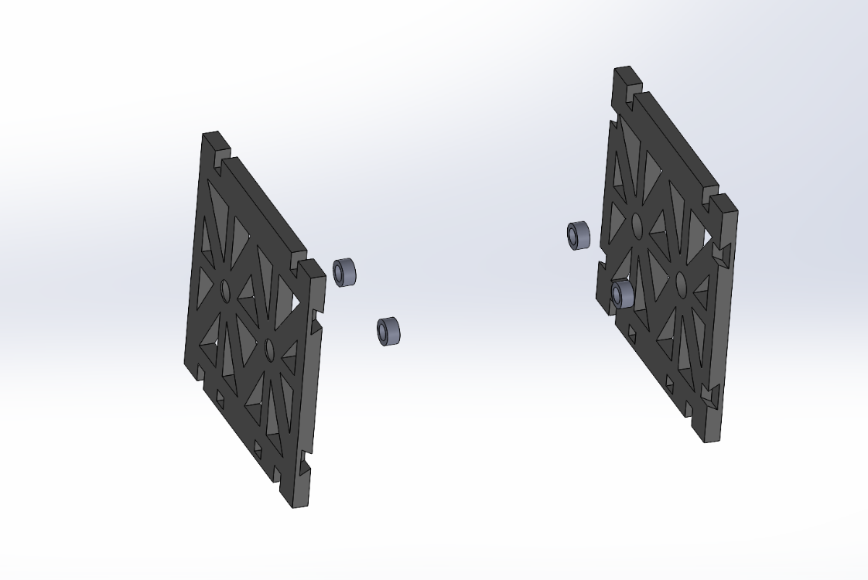

Figure 5 - The Bearings Being Placed in the Side Panels.

Step Four – Take one of the side panels and align it such that the dovetail joints are facing inward, and the two rectangular cutouts are on the bottom. Please note, the rectangular cutouts do not refer to the cutouts outlined in the instructions, they refer to additional cutouts that have been added to only the bottom. Now, take the input shaft and put the end into the bearing.

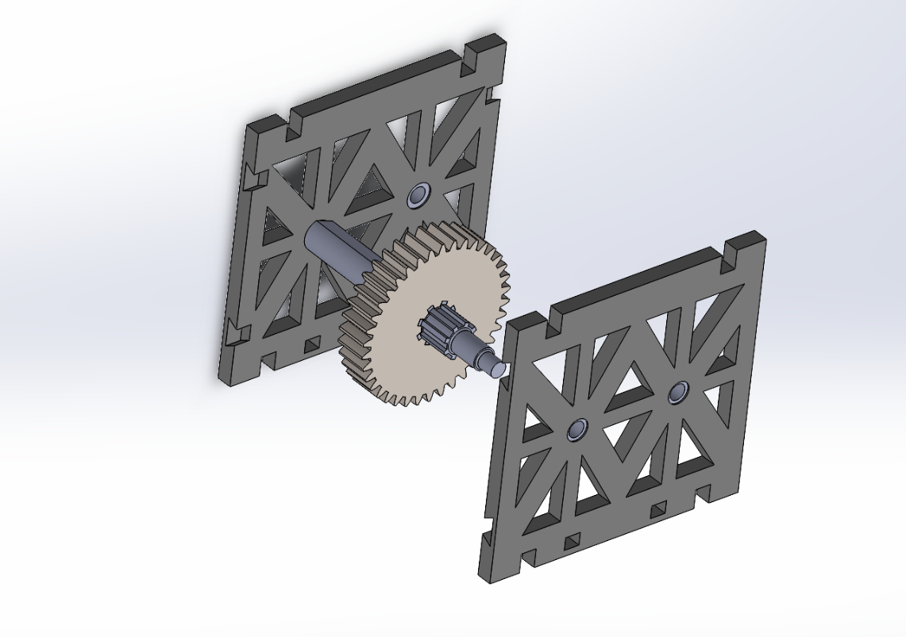

Figure 6 - Input Shaft Being Placed in the Side Panel

Step Five – Take the output shaft and place it into the other bearing of the side panel. Ensure the gear and pinion are mated properly.

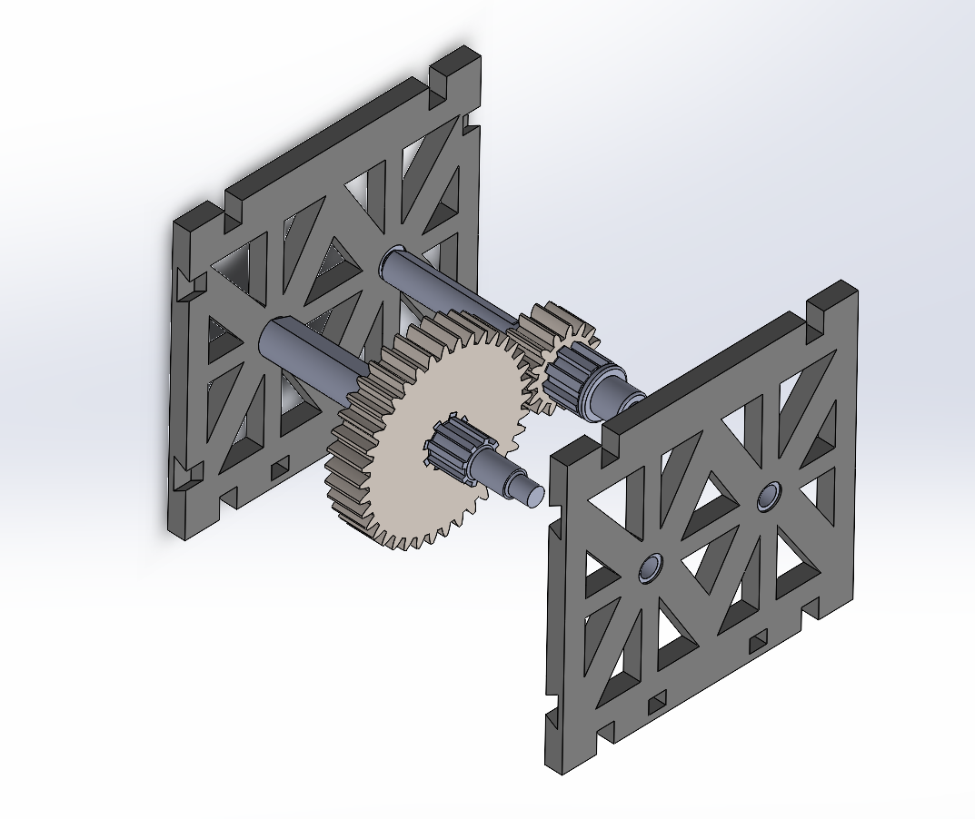

Figure 7 - The Input and Output Shafts Being Put in Side Panel

Step Six – Locate the bottom Panel (shown below) and align it with the side panel such that, the two rectangular pieces align with the rectangular cutouts located on the bottom of the side panel.

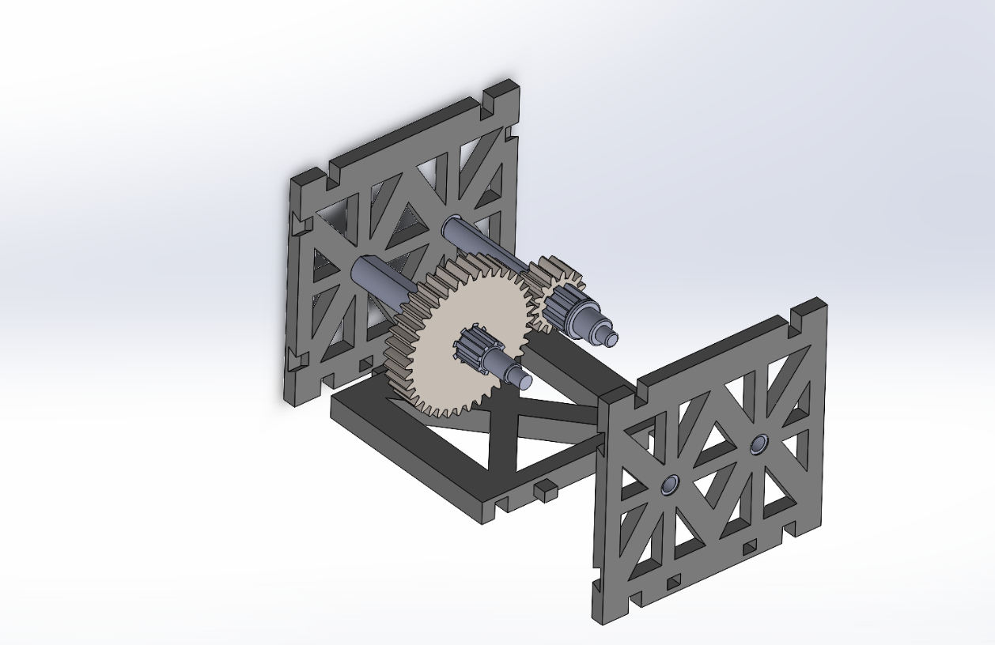

Figure 8 - The Bottom Panel being Attached to the Side Panel

The gearbox should now look like this:

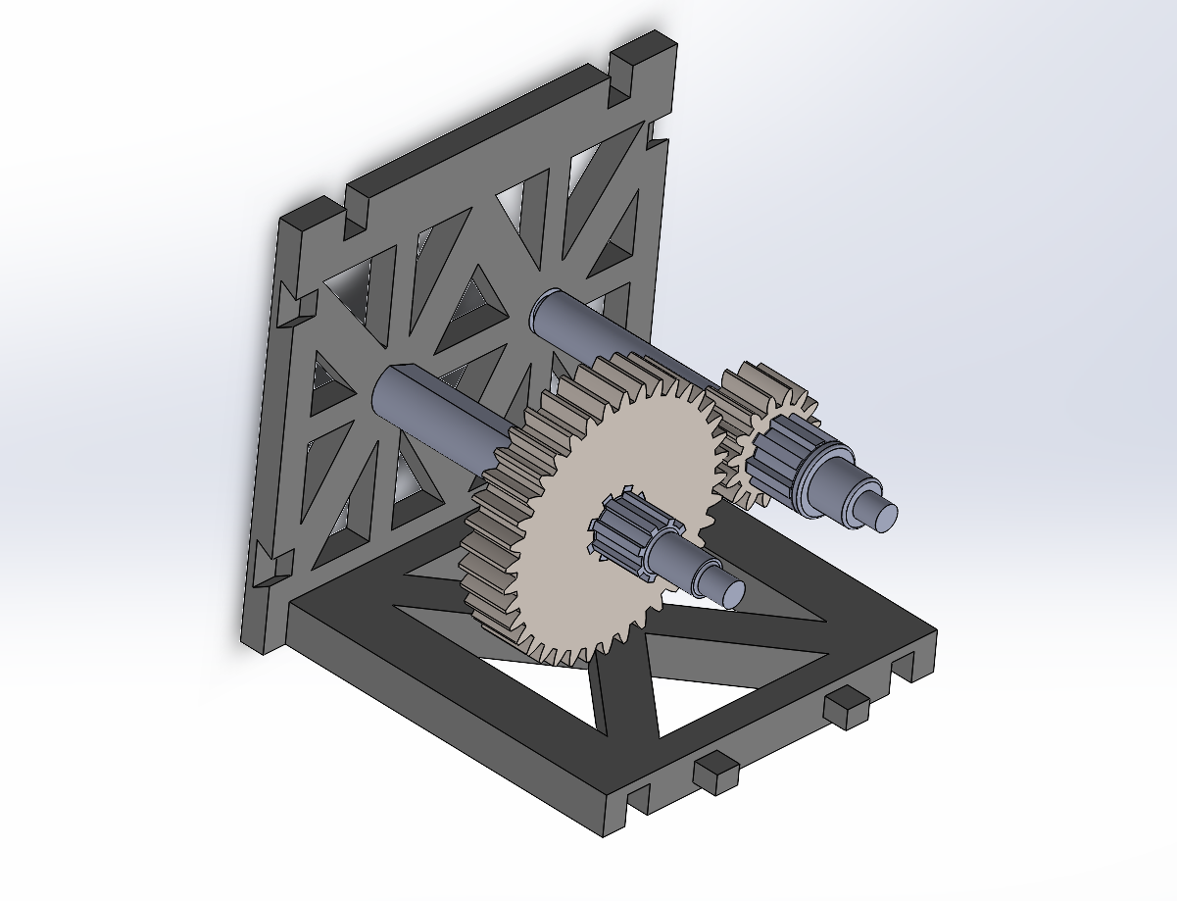

Figure 9 - How the Gearbox Should Look After Step Eight

Step Seven – Take the other side panel and ensure the dovetail cutouts are facing inward and the rectangular cutouts are on the bottom. Now, attach the side panel to the other side of the bottom panel. Care should be taken to ensure that the shafts are guided into the bearings to avoid damage.

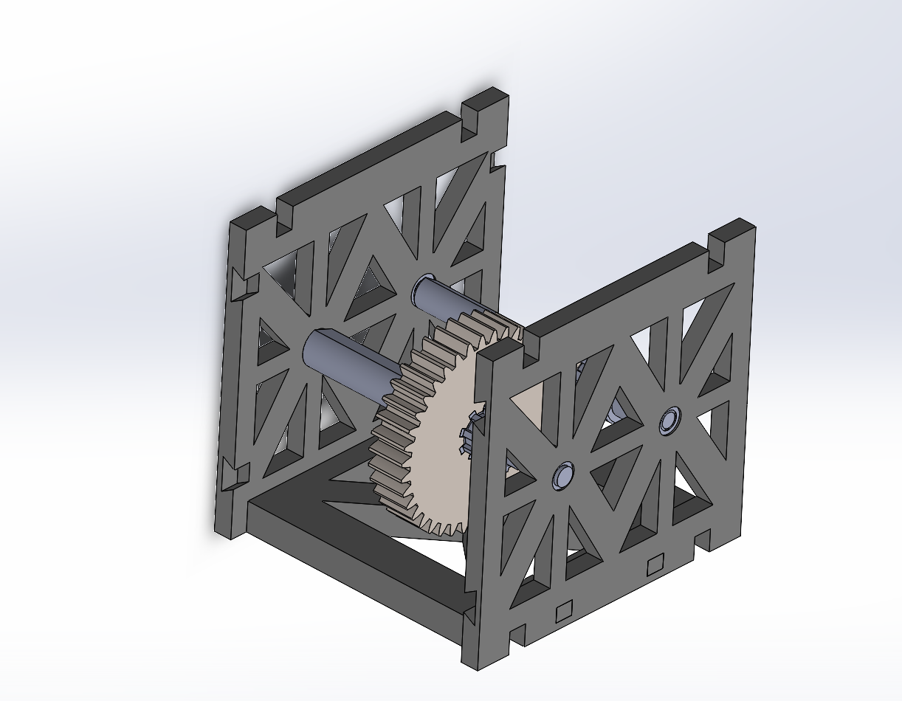

Figure 10 - Attaching the Other Side Panel to the Gearbox

Step Ten – The two remaining pieces are the front and back panels. They should be aligned such that, the cutout on the side aligns with the gear. This ensures that the gear can rotate freely. The gearbox should now look like this:

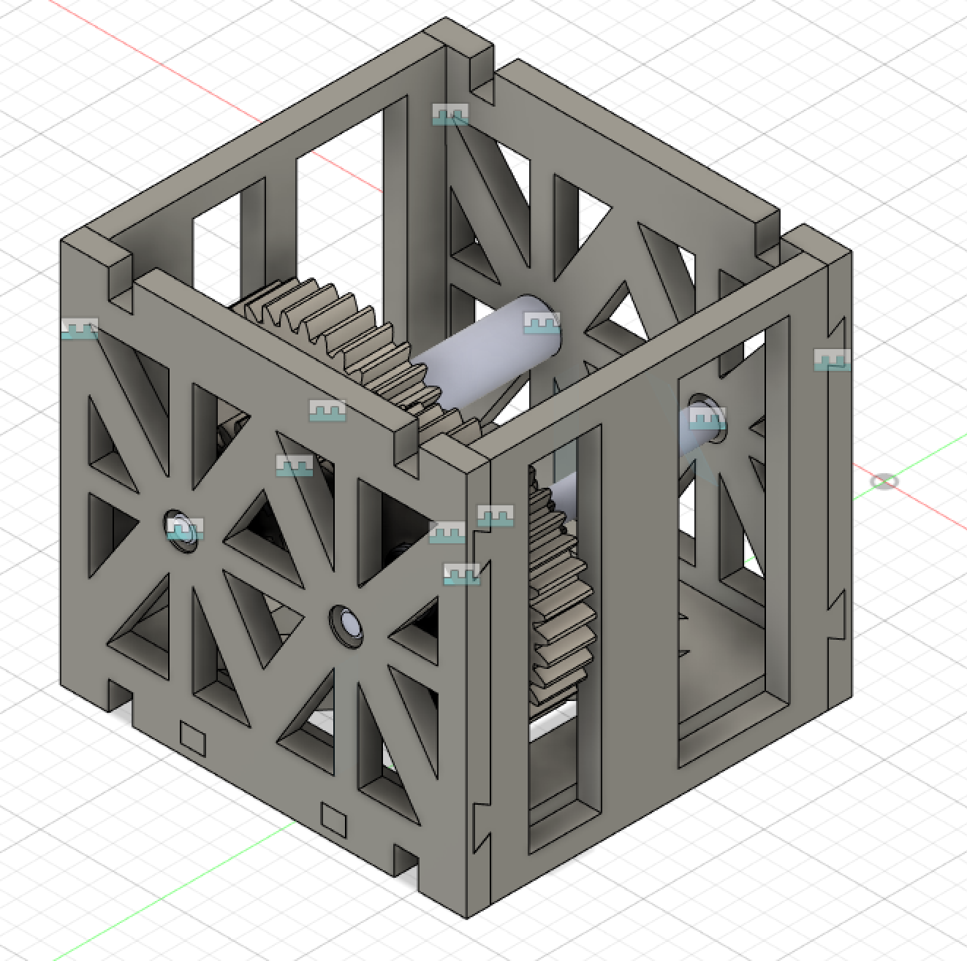

Figure 11 - The Final Gearbox

The gearbox is now complete and ready for use!

### 3.1.2 Parts List

To assemble the gear box you will need the following parts: [4] bearings (part number 6658K116), [1] 15-tooth pinion, [1] 38-tooth gear, [2] front and back panels, [1] right-side panel, [1] left side panel, [1] bottom panel, [1] input shaft, and [1] output shaft.

## 3.2 Technical Specifications Summary

The table below summarizes the parts list outlined in the previous section.

|  |  |  |  |  |
| --- | --- | --- | --- | --- |
| **Part Number** | **Quantity** | **Name** | **Description** | **Drawing** |
| 1 | 4 | Bearings (part number: 6658K116) | The bearings used for the shafts on both the front and back panels |  |
| 1 | 1 | 15- tooth Pinion | Pinion used for both the input and output shaft. |  |
| 2 | 1 | 38-tooth Gear | Gear used for both the input and output shaft |  |
| **Part Number** | **Quantity** | **Name** | **Description** | **Drawing** |
| 3 | 2 | Front and Back Panel | The front and back panels for the housing |  |
| 4 | 1 | Right Side Panel | The panel for the right side of the housing |  |
| 5 | 1 | Left Side Panel | The panel for the left side of the housing |  |
| 6 | 1 | Bottom Panel | The panel for the bottom of the housing |  |
| 7 | 1 | Input Shaft | The input shaft that takes the torque from the motor and transmits it to the output shaft |  |
| 8 | 1 | Output Shaft | The output shaft receives the torque from the input shaft. |  |

Table 1 - Parts List

# 4.0 Future Work Recommendations

Several possible improvements can be made to the gearbox, however, many of these would include small optimizations of the existing design. Because the design saw an overhaul between phases 1 and 2 where it was changed from a single-stage to single-stage shifting gearbox, many of the optimizations that could be done in the future were considered but ultimately scrapped due to time constraints.

The biggest optimization that could be done in future work would be the redesign of gear ratios. While the team is more than satisfied by the current gear design, it was ultimately constrained by the inverse of the speed event gear ratio requiring to be higher than the minimum gear ratio that was required for the hill climb event. The perfect gear ratio to maximize the straight-line speed of the vehicle was closer to between 0.5:1 and 0.6:1, which would increase the speed by approximately 6-30%, depending on the factor of safety of 1-1.2. If the gear ratios were not inversely proportional, a separate and fully optimized gear ratio could be used for each event. This would require a properly written and quite complicated python script, with consideration of a different number of teeth on the pinion and gear, different pressure angles, etc. A 2-stage gearbox could even be designed to increase the range of gear sizes that could be used. This would highly complicate the calculations, which are further affected by the factor of safety.

This brings up another big possible optimization, the factor of safety. This factor takes into account the possible errors in resistive force, the maximum output torque of the motor, errors in printing dimensions, additional weight added to the vehicle by the gearbox, and most importantly energy losses due to heat and friction. While these are unavoidable, the factor of safety can be decreased by precisely measuring the pressure of the wheels to have exact resistive forces or using lighter material and using a higher resolution for the gearbox printing. Lubricant could be used in future designs to decrease the friction and heat generated by the meshing of the gears and rotation of the shafts. All of these additions could be made to allow for more precise calculations and therefore lead to a more efficient design.

Other possible changes to the gearbox could be the addition of cut-outs and holes in the design of the gears. By decreasing the weight of the gears, not only will the gearbox have a lower mass, but the moment of inertia of each gear and pinion could be lowered, increasing the acceleration of the vehicle.

All of the optimizations and changes that could be made a purely theoretical and further recommendations could be made when the design is 3D printed and tested in the two events.

# Conclusion

The gearbox design began as a single-stage gear set, which was modified to a single-stage shifting gear set. This was advantageous as the gearbox could be optimized for both the hill-climb and top-speed events by switching between the 2 gear sets as necessary without compromising the performance of one event for success in the other. The selected gear ratios were 0.4:1 for the top speed event and 2.5:1 for the hill climb event.

The design also ensured that the shafts would be stable and suit the requirements of this project through various analyses, including considering the corrected endurance limit, identifying discontinuities along each of the two shafts and considering stress concentration factors to determine safety factors at all critical points, constructing free-body diagrams and analyzing the impact of forces and torques on the gears and shafts. Bending moment and torque diagrams were constructed for an overall analysis of the shafts. All safety factors considered throughout the design process exceeded 1.

Transitioning from Phase 3 to Phase 4, the material used was changed from AISI 4130 steel to ABS plastic. This required changing the design to remove keyways and retaining ring features and the use of splines to couple components instead. This accounted for the low shear strength of plastic compared to steel, and the possibility of printed plastic layers separating when the gearbox is in use.

The final gearbox design is a single-stage shifting gear set that consists of two shafts, four bushings, a gear, a pinion, and a housing containing 5 panels. Two shafts were designed to each hold either a pinion or a gear depending on the event. The shafts contain splines for the gears which are expected to stay in place by shoulders and through a frictional fit. The shafts also have a D-profile section which is meant to hold the sprockets. A detailed set of instructions are given for the assembly of the gearbox for the hill climb or straight-line event. The housing of the gearbox is designed for ease of assembly, structural strength, and minimal print time.

The components of the gearbox align properly, and this was verified using SolidWorks software. Catalyst software was used to ensure all the components could be oriented in a way that maximizes the strength of components and could also fit in the printer bed area. The overall print time for all the components is 5 hours and 46 minutes, which is significantly less than the time limit of 9 hours.

Potential improvements to the gearbox design include the redesign of gear ratios. The inverse of the speed event gear ratio must be higher than the minimum gear ratio for the hill climb event. While the design ensures good performance in the hill climb event, the ideal gear ratio that would maximize the straight-line speed of the vehicle was between 0.5:1 and 0.6:1. Another improvement that could be made depends on measuring the pressure from the wheels of the car to modify the safety factor. This would allow for design modifications like using lighter materials or a higher resolution of 3D printing. Additionally, decreasing the weight of the gears by using more cutouts and holes in the gear design would reduce the overall mass of the gearbox. This ultimately would increase the acceleration of the vehicle. Other changes could also be made based on testing results.

# Appendix A

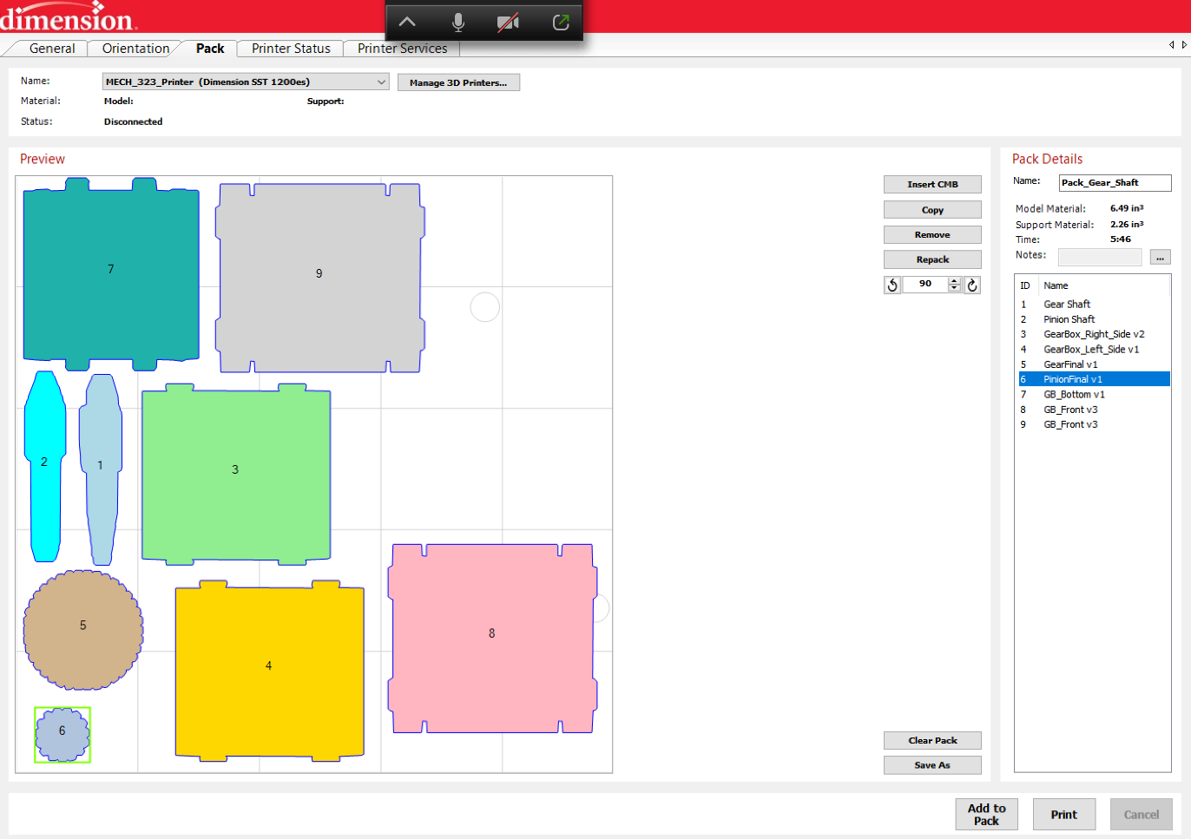

Figure 12 - The Estimated Print Time

# Appendix B – Drawing Package

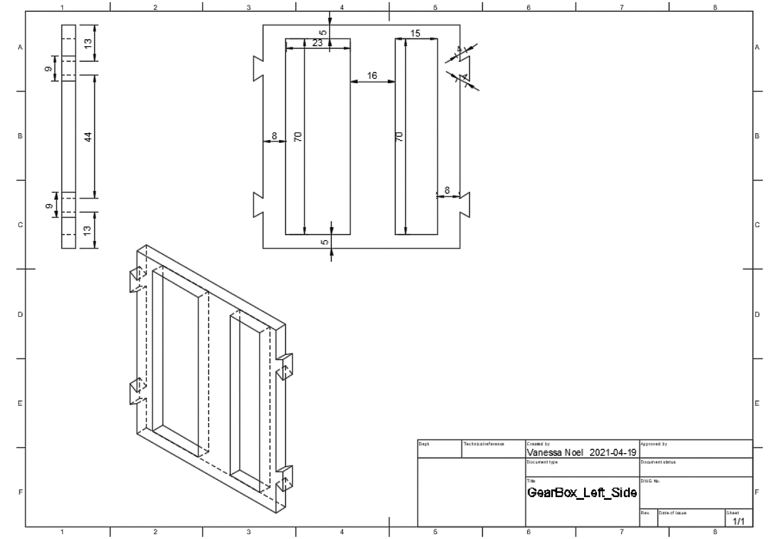

Figure 13 - Dimensions and Drawings for the Left Side Panel

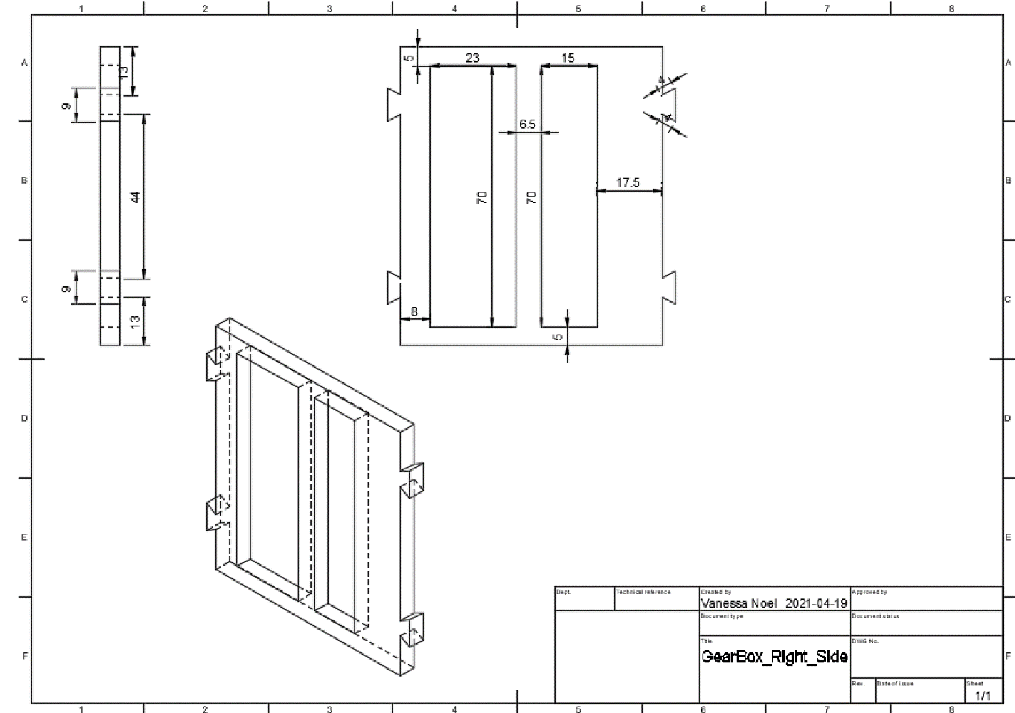

Figure 14 - Right Side Panel Dimensions and Drawing

Figure 15 - Front and Back Panel Dimensions

Figure 16 - Bottom Panel Dimensions and Drawing

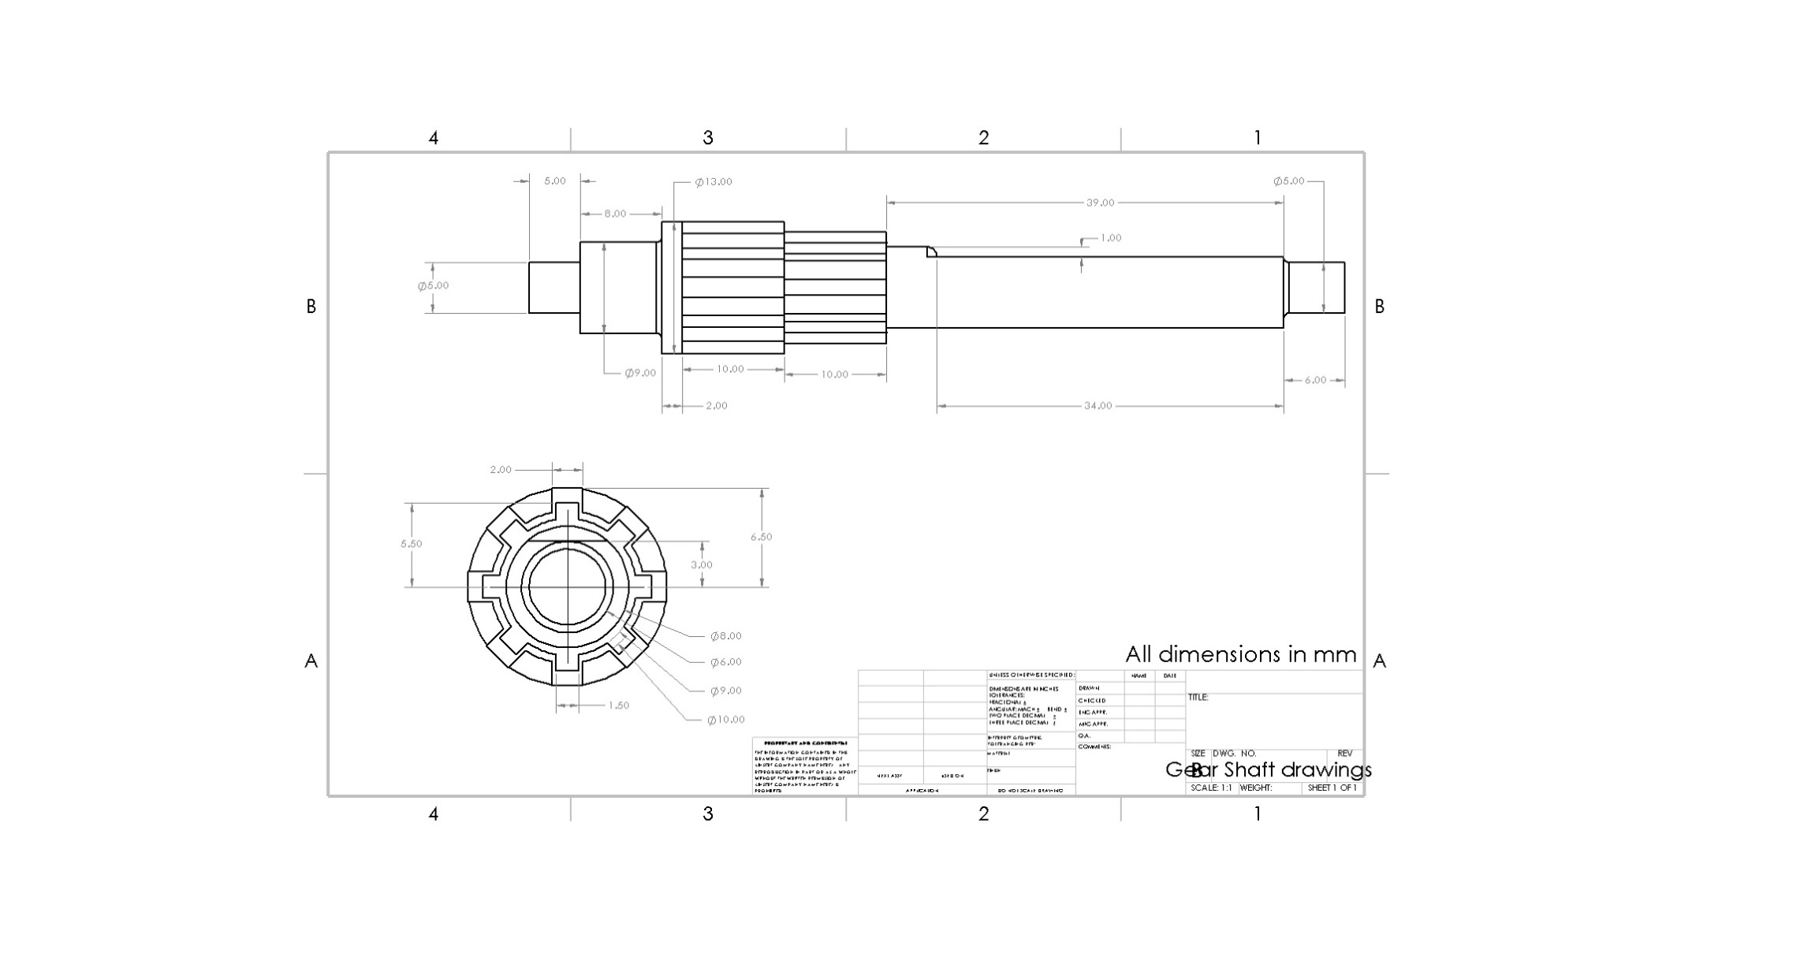

Figure 17 - Output Shaft drawing

Figure 18 - Input Shaft drawing

Figure 19 - Gear drawing

Figure 20 - Pinion drawing

**Phase 4 Summary Page**

*(Attach to the end of your Phase 4 Report on a separate page)*

|  |  |
| --- | --- |
| **Team Number** | **44** |
|  | |
| **Phase Number** | **4** |

|  |  |  |
| --- | --- | --- |
| **Global Design Characteristics** | | |
| **Gear Box Parameters** | **Number of Stages** | **1** |
| **Speed Gear Ratio** | **0.4:1** |
| **Hill Climb Gear Ratio** | **2.5:1** |
| **Vehicle Weights** | **Number of Weights Added** | **0** |
|  | | |
| **Predicted Event Performance** | | |
| **Speed Event** | **2m Time (s)** | **2.448-1.635** |
| **Top Speed (m/s)** | **0.817-1.223** |
| **Motor Operating Torque (Nm)** | **0.8** |
| **Motor Operating Speed (rpm)** | **99.87-149.55** |
| **Hill Climb Event** | **Distance (°)** | **27.47** |